Data paper Meadowatch

STRUCTURE:

Abstract:

1. Background & Summary

*Importance, relevance, and approach.*

1. Methods

Study design

Data collection: Scientist data and public-source data

Data processing and updating

Data availabiltiy and privacy

Microclimate and snow cover data

Applications

1. Technical Validation

Scientist vs. public source validation

Climate vs. macroclimate validation?

FIGURES:

***Figure 1: Location of trails with elevation (left). Number of trails per year (top right) and months (bottom right) for each trail.***

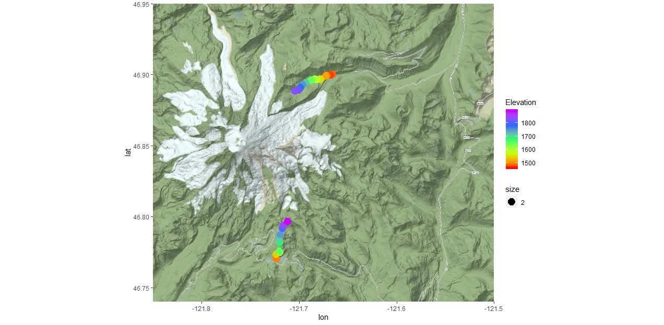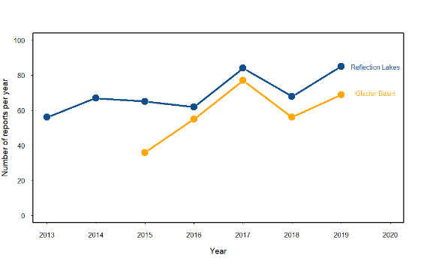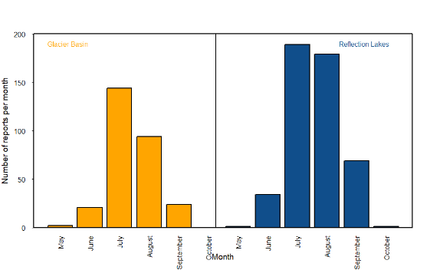

**Figure 2: Species composition and replication per trail (color code is the same here, but this can be done with vectors to make it easier to compare the overlap). Size is number of reports with info on this species per trail.**

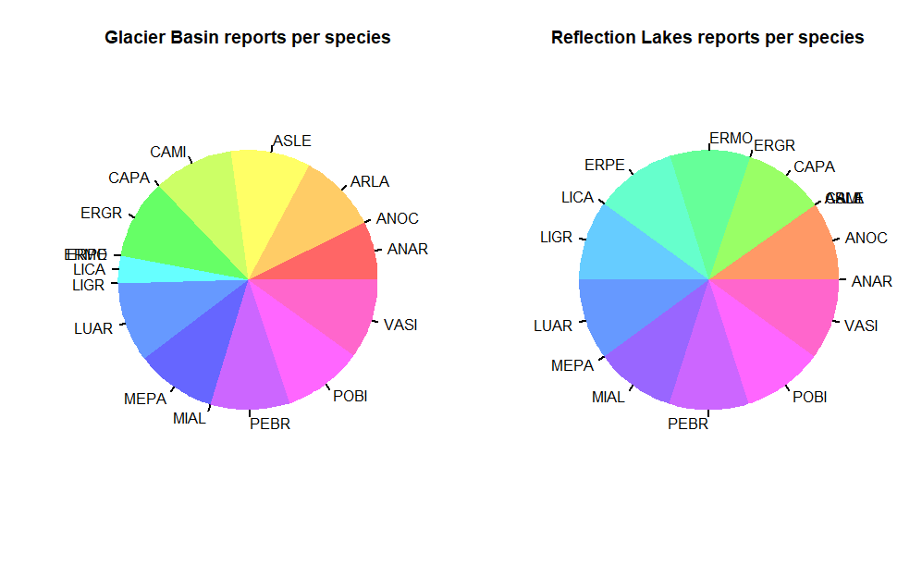

*Yes, two horizonal barplots with matching colors and lines would be a lot clearer.*

**Figure 3: Temporal resolution. (colors as above, for each year it displays the time since the last day with at least with MW report), horizontal lines are daily resolution, and weekly resolution.** The areas with no data will be shaded red, This is kind of a lot of graphs, so a better way of summarizing this may be useful. They can be combined into one per trail,meaning for wich days of the year there is data, but that is less useful I think for those interested in using the database

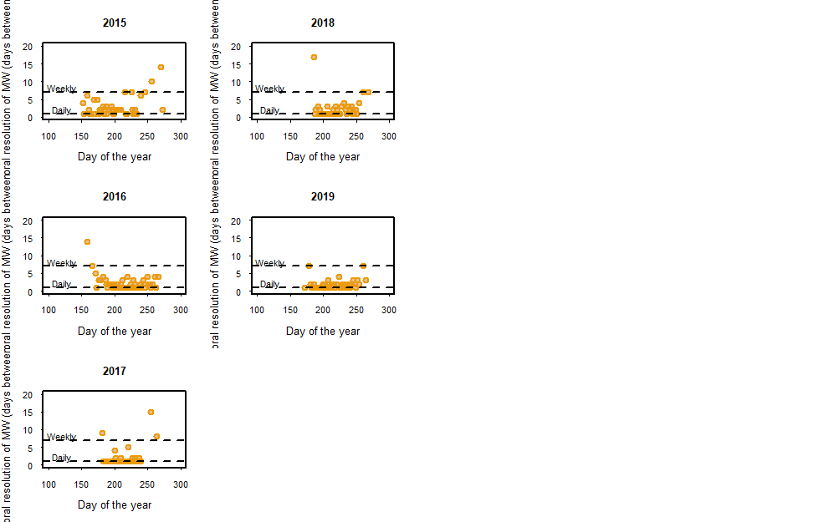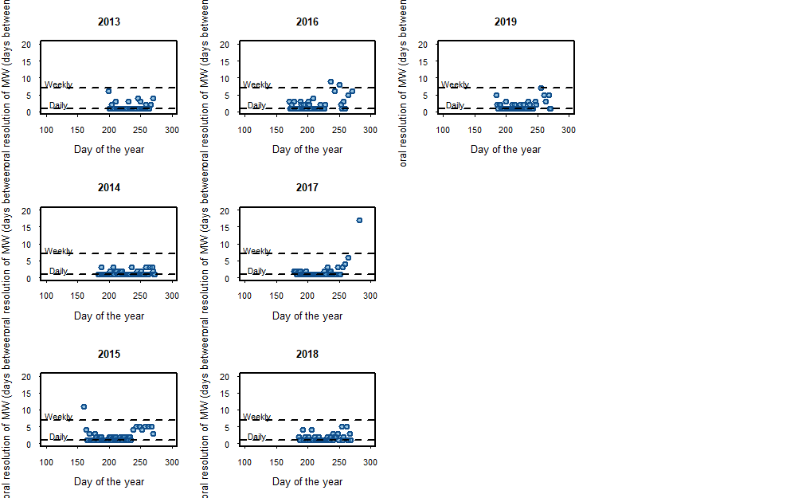

**Figure 4: Flowering peak times for certain species** (place for the interactive figure that Aji was playing with?)

**Figure 5: Data validation comparative scientists vs. general public**. (this could be either a graph of estimates scientists vs. estimates public, or a confusion matrix for each of the states. Here something I just made up in 5 minutes (VALUES NOT REAL!!!), the kappa value for each state can be calculated. This could also be done per species to see if there are particularly tricky ones for non-scientist. (I would do the logos properly if we go for something like that).